rule list.

7. Now, if you go to the page using your slug URL, such as index. php/blog-post/super-quote- title-i/, you will get a result like similar to that in step 3:

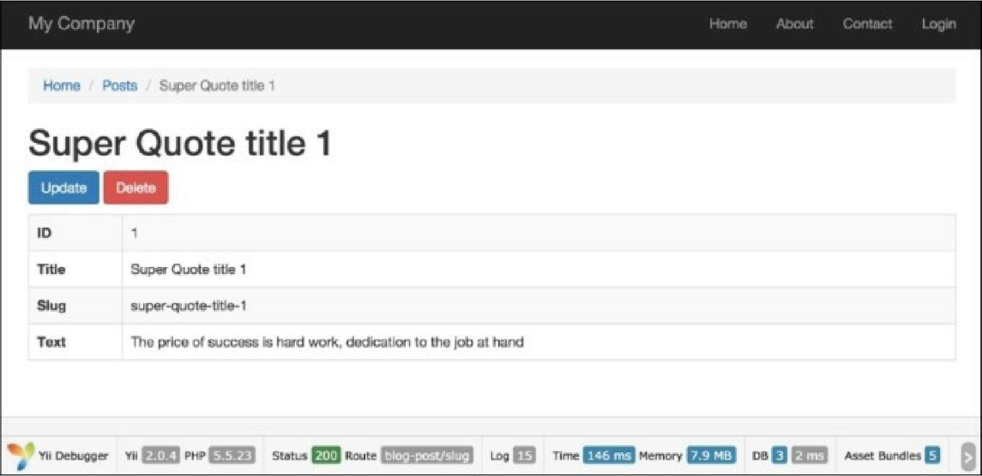

See also

For further information, refer to:

* [http://www.viiframework.com/doc-2.0/yii-behaviors-sluggablebehavior.hrml](http://www.yiiframework.com/doc-2.0/yii-behaviors-sluggablebehavior.html)
* [http://www.yiiframework.eom/doc-2.0/guide-runtime-routing.html#url-rules](http://www.yiiframework.com/doc-2.0/guide-runtime-routing.html%23url-rules)